

ONLINE MOVIE STORE-
CINEMAX

CS 6314.001

FINAL PROJECT

Online Movie Store - CINEMAX

 | CONTENTS
Sr. No. | Topic
1 | PROJECT DESCRIPTION
2 | DATABASE DESIGN
3 | IMPLEMENTATION LANGUAGES/FRAMEWORK
4 | SCREENSHOTS
5 | TEAM MEMBERS DETAILS

- WORK DIVISION DETAILS

1
Online Movie Store - CINEMAX

Project Title

Online Movie Store

Name of the Website

Cinemax

Project Description:

- Cinemax is an E-Commerce Web Application of a movie store. DVD’s of different movies are sold on this site, and users can browse through the different movies available and then decide what they want to buy.

- Movies are all listed in the “Shop” section of the site. Users will be able to view the different movies available for purchase on the site without logging in, but they cannot buy a movie from Cinemax unless they are registered users of the store. For this the site provides a Signup page where new users can register themselves. Different validation

rules are applied on the form fields of the signup page which are mentioned as follows:

- No fields can be empty

- Length of username should be greater than 4.

- Email ID should be entered in the proper format.

- Username and email entered by the user should not already exist in User Information database.

- Length of password should be at least 8, should contain at least one numeric character, at least one lower case letter, at least one uppercase letter and at least one special character.

- Data entered in Password and Repeat Password fields should be the same.

- Data entered in Phone fields should only contain numeric characters.

Md5 hashing algorithm is used in order to has the password entered by the user and store it in the database. This makes storage of sensitive information like passwords more secure.

- Users have to login in order to purchase movies on the site, and for this User Login page is created which contain fields like Username and Password. Validation rules have been applied on these inputs fields which makes it mandatory for the users to enter data in both fields.

- Once the user has logged in, user can go in the “Shop” section and will be able to see the “add to cart” option for each movie listed. Movies are only listed on the Shop page only if the available quantity of that movie is greater than zero in the database.

- To make searching convenient for the users, site provides different filtering options, where the user can select the price range/genres/keywords or all three of their desired movie and the site will filter the movies displayed to the user accordingly.

2
Online Movie Store - CINEMAX

- Pagination functionality is provided on the web site, such that 6 movies and options related to that are displayed per page. Based on the any new movies added or any movies deleted or based on the filtering enforced by the users the number of pages will automatically adjust accordingly.

- Once the user decides the movie he/she wants to buy, the user will click on the ‘Add to Cart” option. If the user clicks on the “Add to Cart” option of the same movie multiple times, the quantity of the movie increases accordingly in the Cart page.

Users can add multiple movies at a time in cart.

When user adds any movie to the cart, the site reduces the available quantity of that particular movie by 1.

- Once the user is done shopping, user will go to the cart page. All the movies selected by the user along with their appropriate quantity are listed in this page. The user has option to delete a selected movie or to change the quantity of the selected movie.

When user deletes any movie the available quantity of that movie is increased accordingly.

When the user changes the quantity of the movie in the cart and clicks on the “Update” button, the site will first check if the quantity entered by the user is greater than the available quantity and then only confirms the updation, else appropriate error is displayed to the user.

- Once the user is ready to buy, he/she will click on the Checkout button and the order will be successfully placed.

- After user purchases any movies, entry is made in the History page. By going to the History page, the user will be able to see all the movies that the user has purchased form Cinemax.

- When an Admin User Logs in to Cinemax, he will be able to see additional options on the Shop page. He will have an option to Add a new movie, Update or delete an existing movie. When admin deletes a movie, that movie can no longer be seen in the Shop page. Soft delete has been implemented in the database so that even though admin deletes a movie, it can still be seen in the History page of the users who have previously bought the same movie.

3
Online Movie Store - CINEMAX

Database Design:

1. ER Diagram
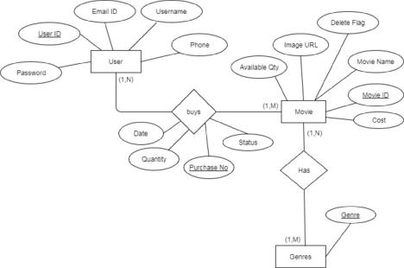

4
Online Movie Store - CINEMAX

2. Relational Model
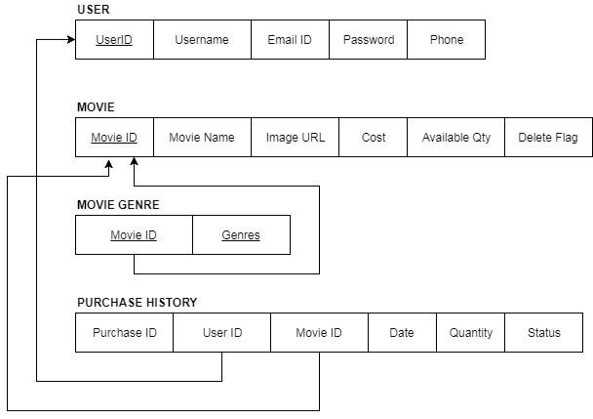

5
Online Movie Store - CINEMAX

Implementation Languages/Frameworks:

Front-end design

We used HTML and CSS to design the layout of the pages in our website. Along with these we used Bootstrap 3.3.7 for adding more effects to the user interface design such as Slider and Modals. Sublime Text 3 was the editor used to develop this project.

For client-side scripting we used jQuery to handle various events and dynamic handling of content and design of the page along with AJAX for api calls.

Back-end design

We used relational databases for the database component. The database used is normalized to Third Normal Form. We used Mamp Server 3.3.1 and MySQL to handle the database for our website. For server side scripting, we used PHP.

6
Online Movie Store - CINEMAX

Screenshots:

1. User Registration Page
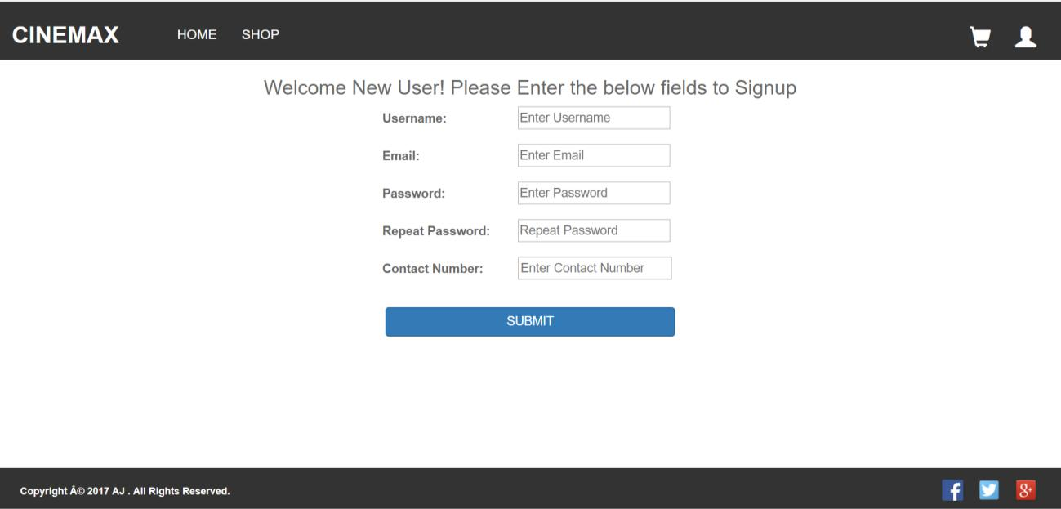

2. Login Page
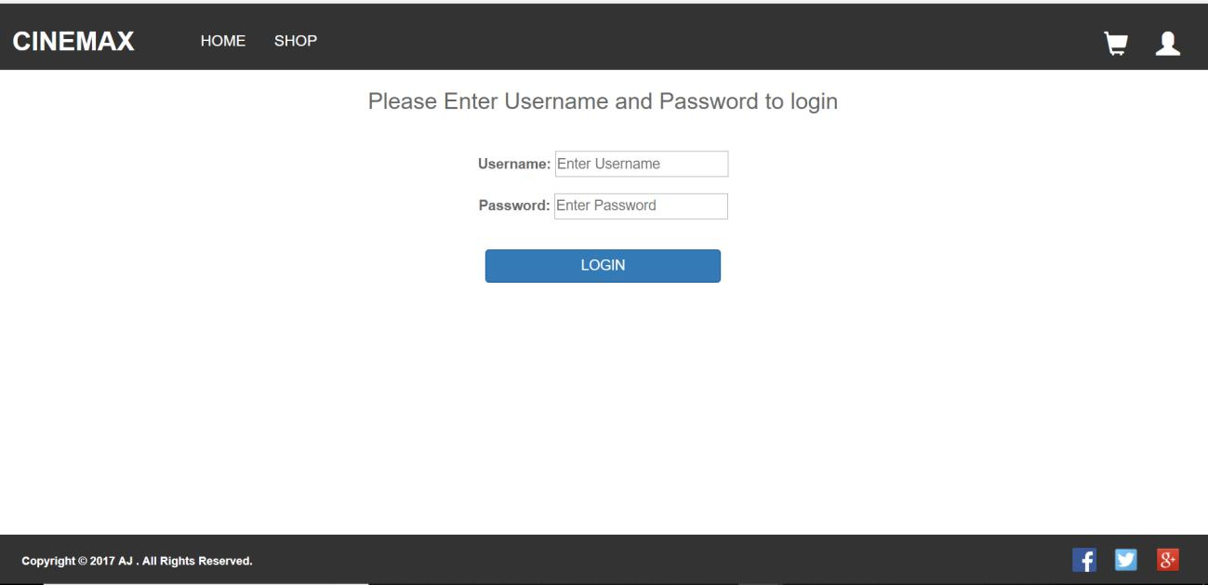

7
Online Movie Store - CINEMAX

3. Home Page
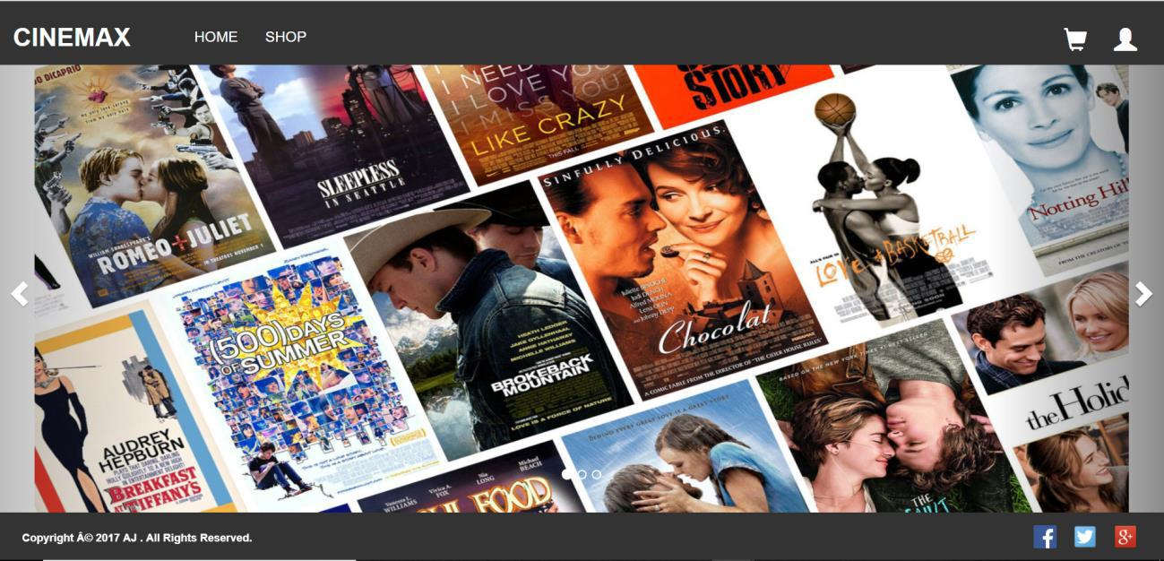

4. Shopping Page
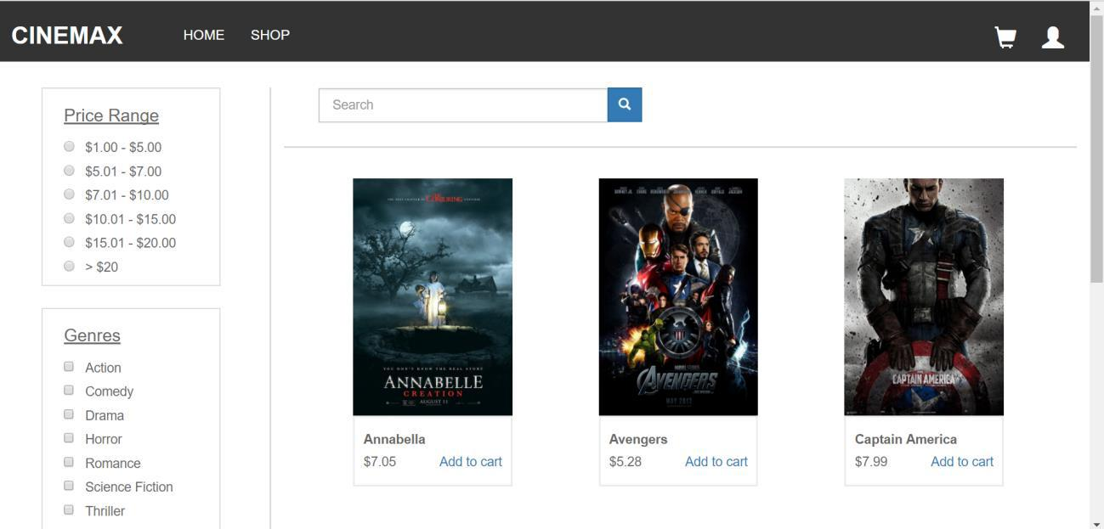

8
Online Movie Store - CINEMAX
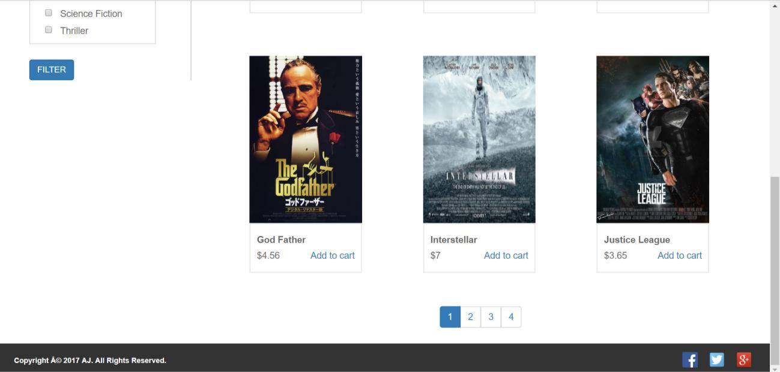

5. Cart Page
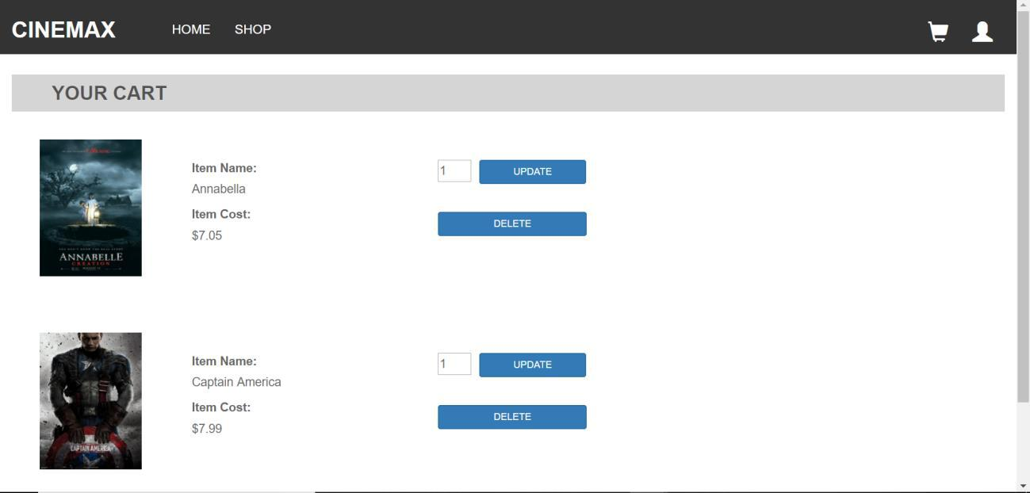

9
Online Movie Store - CINEMAX

6. History Page
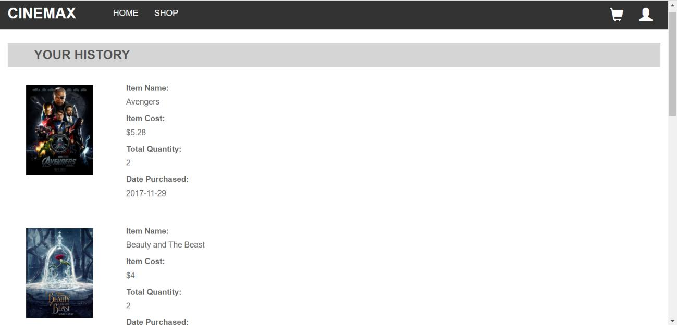

- Admin Pages:

  - Shop Page for admin with extra functionality of adding a new product, updating existing product and deleting a product.
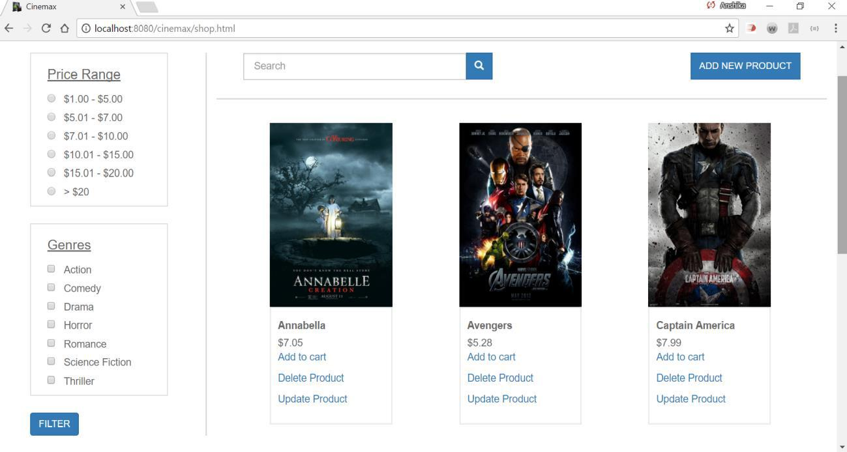

10
Online Movie Store - CINEMAX
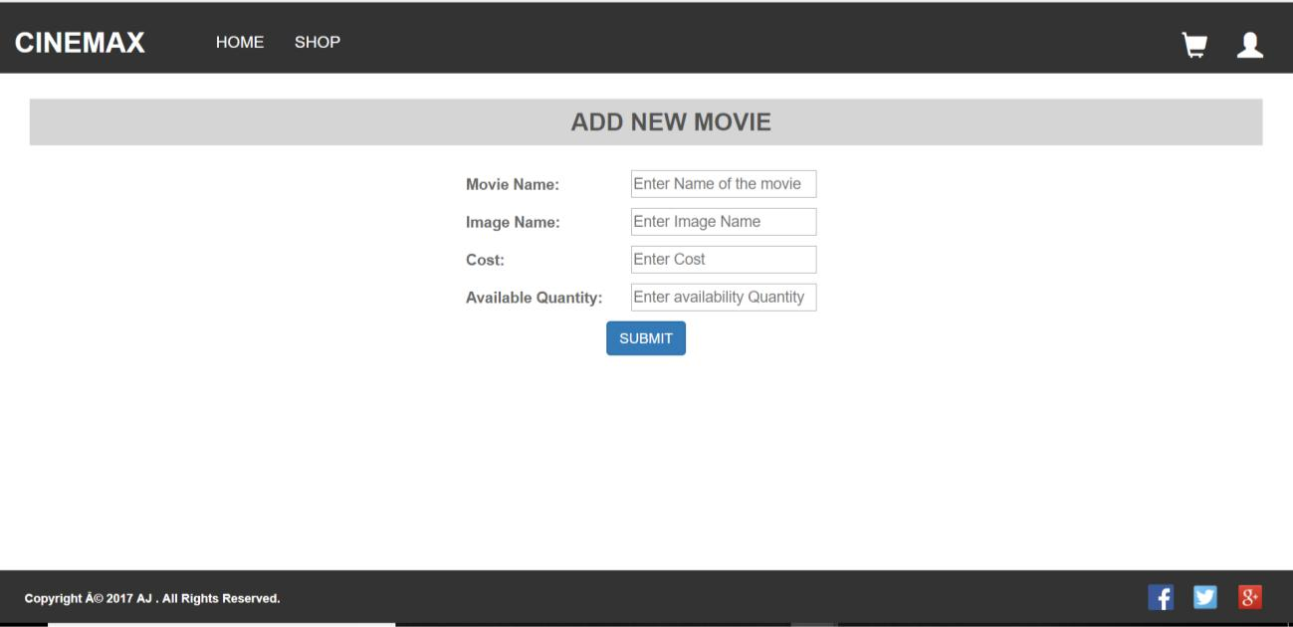
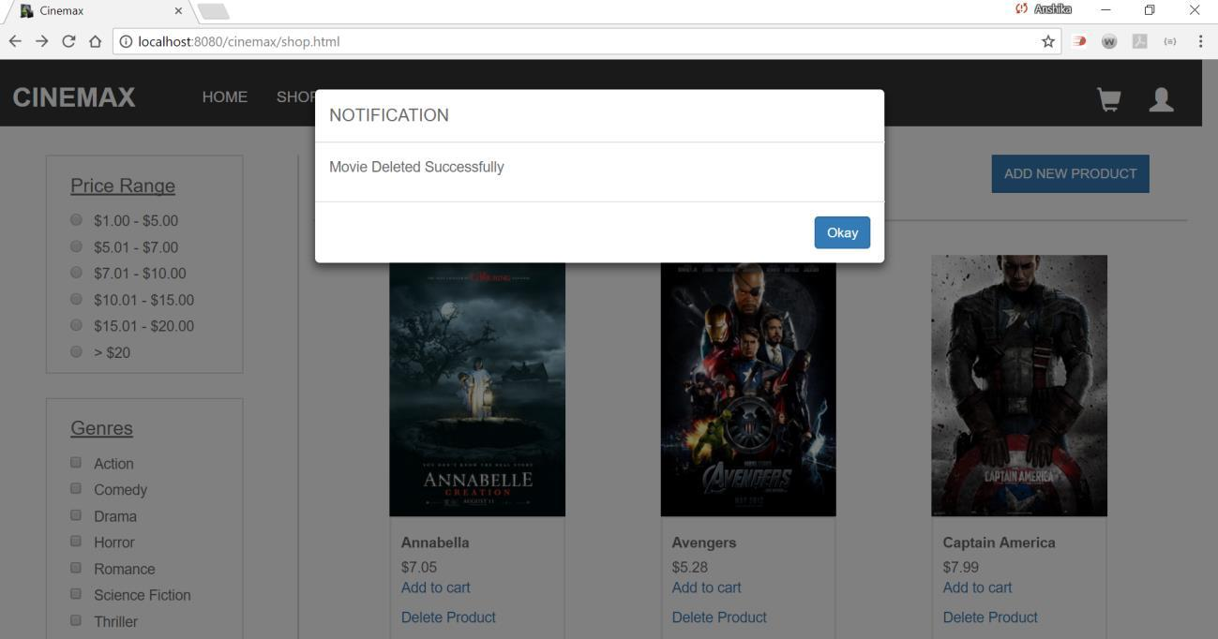

11

